**Strategic Workforce Optimization: Development of HR Management System with Prescriptive Insights for Carigara Local Government Unit**

**Capstone Project**

**Presented to the Faculty of Information Technology Department**

**Eastern Visayas State University – Carigara Campus**

**Carigara, Leyte**

**In Partial Fulfilment of the Requirements for the Degree of BACHELOR OF SCIENCE IN INFORMATION TECHNOLOGY**

ROTAIRO, CHRISTIAN KIT V.

ROCHA, ARWIN O.

RAGRAG, JASMIN C.

ADRALES, MARIS

**CHAPTER I**

**INTRODUCTION**

Information Technology (IT) is altering established methods in all industries at a time when technological innovation has come to be seen as a sign of progress. The changing nature of governance, especially within local government entities, is the driving force behind this study. With a focus on maximizing IT potential, the study aims to create an advanced HR Management System that not only streamlines administrative processes but also integrates features such as Advanced Analytics and Prescriptive Insights, tailored to the specific context of the Carigara Local Government Unit. The Carigara Local Government Unit, which is located at a central point in the public sector, is aware of the potential for IT-driven solutions to increase operational effectiveness, service delivery, and promote data-driven decision-making (Rousseau and Barends 2011). Traditional HR management systems often rely on manual and paper-based processes, leading to delays, errors, and a lack of transparency. This hinders organizations from making informed decisions about their workforce, such as resource allocation, training program development, and future staffing planning.

As organizational across sectors to embrace digitalization, local government units have come to recognize the potential of IT solutions to streamline their operations, enhance efficiency, and better serve their constituents (Chowdhury et al. 2023). This HR Management System focus on the User’s Authentication, Document Organizer, Prescriptive and Tabulation. The "Users Authentication" system acts as the guardian of data security, making sure that only those with permission can access sensitive data. This element is essential in maintaining the integrity and confidentiality of personnel records and other confidential data. By implementing strong authentication measures, such as multi-factor authentication and role-based access controls, the system ensures that sensitive employee information remains protected from potential breaches.

Moving forward, the "Document Organizer" takes centre stage. With the help of this function, it will be easier to effectively manage the many documents that are essential to local government activities. This system simplifies document management, storage, and retrieval by combining a digital repository. The time spent looking for important documentation is drastically reduced by categorizing papers based on relevancy and providing quick, safe access to authorized individuals. This encourages good departmental collaboration and helps create a paperless office environment.

Furthermore, the "Tabulation" acts as a link between knowledge and understanding. Through well-structured tables, charts, and visualization complex data is distilled into easily understandable formats.

**Statement of the Problem**

The efficiency of work in HRMO is extremely important to the Local Government Unit since it is critical to making a smooth workflow and a safe workplace. This research will largely address the following question.

* How will the web system manage the document organization?
* How will the system optimize and display capabilities to provide a user-friendly interface that facilitates efficient data entry, retrieval, and analysis?
* How will the web app system integrate the tabulation?
* How will the system leverage prescriptive insights derived from data analysis to provide actionable recommendations that optimize HR processes?

**General objective:**

To enhance the efficiency, effectiveness, and decision-making capabilities of the Carigara LGU's HR operations through the integration of a comprehensive HR Management System, leveraging advanced analytics and prescriptive insights to optimize workforce management, employee engagement, and organizational performance.

Specific objectives:

* To develop a system that will organize the documents
* To implement a user-friendly and intuitive interface that caters to the diverse needs of HR personnel regardless of their technical expertise.
* To develop a system that can tabulate.
* To develop a system that applies prescriptive insights that will auto prescribe and will integrate into the web app system.

**Scope and Delimitation**

The HR Management System for the Carigara Local Government Unit will be the subject of this study. The scope of this project was to develop and implement an innovative HR Management System with Advanced Analytics and Prescriptive Insights within the Human Resource Management Office (HRMO) in Carigara, Leyte. The system can integrate solutions for HR document management, and heightened security measures, and aims to create tabulation and analytics of the employees together with their prescriptive. This system will reduce the time and effort of the personnel and other employees inside the office in locating and retrieving the HR documents.

However, this project has some limitations or delimitations. First, only documents within the HR Management Office of the Local Government Unit of Carigara, Leyte were eligible for use of the system. The study will be focused specifically on the Carigara Local Government Unit. The findings and conclusions may not directly apply to other local government units or organizations in different regions or countries. Second, the system’s recommendations may be affected by some factors and its effectiveness may depend on how it’ll work and be handled inside the HR Management Office.

**Significance of the Study**

The result of this study that will be conducted by the researchers will give benefit to the HRMO personnel, other staffs/employees inside the Local Government Unit in Carigara, Leyte, Citizens and Constituents, other Local Government Units (LGU), HR Departments, Academic and Research Communities, the Researchers or the Proponents, and the Future Researchers. The significance of this study is multifaceted.

Hrmo Personnel.Firstly, it will contribute to the HR Personnel who are assigned in managing important documents of different employees, by providing a more precise and accurate method of implementing an HR Management System with AAPI, this will help in ensuring swift access and will ease showing analytics of every employees.

Staffs and Employees. The employees working for the Carigara Local Government Unit will benefit from the implementation of the HR Management System.This research will help them to be more knowledgeable on how to retrieve important HR documents when necessary. This will also be a great help for the employees to lessen their time in managing any other type of documents.

HR Department.The study will have substantial advantages for the HR department. They will have access to strong analytics and insights, enabling data-driven choices for hiring, performance management, development of employees, and training. The system will streamline HR processes, reduce administrative burdens, and enhance their ability to support the organization strategically.

Citizens and Constituents.As the HR Management System enhances HR processes, it can lead to improved public services provided by the Carigara Local Government Unit. Effective HR procedures produce more qualified and driven workers, which improves service delivery and overall governance for Carigara's constituents and inhabitants.

Other Local Government Units (LGUs) and Organizations.The study can serve as a model for other LGUs and organizations interested in adopting advanced HR management practices. It showcases the benefits of leveraging technology, analytics, and prescriptive insights to enhance HR operations and overall organizational performance.

Academic and Research Communities**.** The study can contribute to academic research and knowledge in the fields of HR management, analytics, and organizational development. It may provide insights into best practices and innovative approaches for similar studies in the future.

Researchers. The outcomes of this study will also be benefited by the researchers, it will be an honour for them to succeed in this study/research.

Future Researchers. This study will be beneficial for them too, as this will serve as a guide to their future study that is related to the topic.

Overall, the study's beneficiaries go beyond the Carigara Local Government Unit alone because its conclusions and application may benefit a number of stakeholders, resulting in improved public services, more effective government operations, and better resource management for the community.

**CHAPTER II**

**REVIEW OF RELATED LITERATURE AND STUDIES**

The purpose of this Review of Related Literature (RRL) is to delve into the existing body of research and knowledge surrounding HR Management Systems with Prescriptive Insights, with a particular focus on their impact on employee performance and engagement within local government units. This RRL intends to provide light on the advantages, difficulties, and opportunities presented by these cutting-edge systems in the context of local government organizations by examining pertinent research, reports, and academic articles.

**Related Literature**

Human Resource (HR) Management Systems with Advanced Analytics & Prescriptive Insights have become essential tools for streamlining HR procedures and promoting data-driven decision-making in today's fast-paced, technologically advanced society. These innovative systems integrate advanced analytics and prescriptive insights to enhance talent management, employee performance, and engagement across various sectors, including local government organizations. An HR system can be defined as a combination of HR practices "aim to achieve some overarching results" and "that are espoused to be internally consistent and reinforcing" ([Lepak et al., 2006](https://journals.sagepub.com/doi/full/10.1177/0149206318818718#bibr98-0149206318818718): 221). HRM is primarily focused on ‘‘the pattern of planned HR deployments and activities’’ that are intended to help organizations to achieve their objectives (Wright and McMahan (1992) p. 298). Human Resource Management must be undertaken taking into consideration. It can be viewed as a field of study that is focused on the requirements of the organization as a whole; geared at investigating the methods and techniques that can be used using personnel in the context of organizational objectives (Armstrong and Taylor, 2014). However, for a Human Resources Management to be appropriately effective and help in making alterations and introductions that yield positive results or have profitable implications, it should be oriented towards gaining a deeper insight into behavioural particularities and characteristics of its employees.

Rasmussen and Ulrich’s (2015) paper investigates the basis for the assertion that HR analytics by offering data that is supported by statistics and has been independently verified, to add value to managerial and HR decision-making. According to the study, in order to stop HR analytics from becoming another "management fad," it should try to change the status quo. A strategy used by HR and related endeavours to make sure it is efficient in terms of producing tangible and material results. Decision-making has been identified as one of the most critical organizational processes including employee behaviour, work performance, levels of motivation and the amount of stress levied on employees (Griffin and Moorland, 2011). It is essential that the type of HRM procedures used be linked and coordinated with broader standards and directives for employee conduct competing objectives.

**Foreign Related Studies**

According to a study on HR ANALYTICS: A MODERN TOOL IN HR FOR PREDICTIVE DECISION MAKING, HRM is oriented towards identifying tools and measures, and relies on the basic principle that the employers and employees can work together and realise shared goals within the operative space of hierarchies and structured systems. HRM includes a variety of established strategies and practices that have been proven to be effective and also the creation of new ones particular to organizational context (Marchington, Wilkinson, Donnelly and Kynighou, 2016).

Human resource analytics is a relatively novel intervention in the larger domain of HRM, and it refers to the use of statistical tools, measures and procedures, which can be used in employing and masking the most effectual decisions such as HRM strategies and practices. It is often referred as people analytics or talent analytics or workforce analytics. HR analytics can be understood as being more credible because it provides statistically valid data and evidence that can be used in the process of creating new strategies during the implementation of existing HR strategies and other measures (“People Analytics”, n.d.).

Shu Wang and Mary K. Feeney on their study Determinants of Information and Communication Technology Adoption in Municipalities they applied supervised learning that Local governments use various technologies to enhance responsiveness to citizens’ demands and to improve efficiency. Public organizations have long been stereotyped as being highly bureaucratized and slow to innovate. Despite their rigid structures and the lack of flexibility to accommodate client and citizen needs (Bozeman, 2000; Rainey, Pandey, & Bozeman, 1995), public managers have made efforts to adopt organizational innovations.

According to E. Guest, on a study Human Resource Management and Performance: A review and research agenda, the Impact of Human Resource Management on performance has become the dominant research issue in the field. There has been a rash of studies demonstrating a positive association between human resource management (HRM) and performance, providing encouragement to those who have always advocated the case for a distinctive approach to the management of human resources.

As per Ghani and colleagues (2022), the hiring procedure can vary across different companies and job roles. The duration of the process should not exceed two to four weeks. Ineffectiveness in recruitment can negatively impact the candidate's experience, leading to damage to the organization's reputation and the loss of highly skilled individuals. Additionally, the recruitment manager and recruiter might experience reduced efficiency and potential exhaustion in the long run.

Bandi et al. (2021) delve into the significance of Data Analytics instruments in Human Resource Management in their research and they reached the conclusion that the utilization of data analytics is highly beneficial in all HR aspects. By employing this statistical instrument, the HR department is capable of making well-informed decisions. The researchers specified that HR analytics concepts are highly useful for measuring employee performance, informing decisions about salary and promotions, increasing employee retention, examining employee engagement, and measuring employee development and learning outcomes.

One form of data analytics is prescriptive analytics and in the study conducted by Samtani (2022), the researcher shows how prescriptive analytics can assist HR leaders specifically in Ireland in examining the trends and procedures for recruitment efficiency and performance oversight, regarded as enforced under comprehensive principles of HR service's influence on the work environment. This study has employed a utilization of qualitative semi-structured interviews that is reliable in the present research as it is grounded on assessing the efficacy of prescriptive analytics in HR. Since this is an exploratory study, semi-structured interviews with ten HR specialists have been utilized. The findings of the interviews uncovered that the majority of the interviewees exhibited a strong interest in HR Analytics. This is attributable to the immense importance of HR Analytics in the activities of human resource management. The majority of the participants from the HR field in the project disclosed that the utilization of prescriptive analytics is not difficult in itself as it encompasses the historical records of the employees and their performance criticality is dependent on the availability of organized and specified data. The conclusions of the study propose that organizations should incorporate the organizational data generated by HR analytics into their decision-making process.

Prah (2020) stated that prescriptive analysis in HR involves examining the resumes, ATS, job descriptions, and HRIS to forecast talent acquisition outcomes. The term prescriptive analytics refers to the field of data intelligence that allows businesses to blend the insights of descriptive analytics with a forward-looking approach. HR users can learn to explore and shape future considerations in the recruitment process, but prescriptive analytics also offers guidance on what actions the organization should take to improve employee performance management. It utilizes historical data, including individual skills, productivity, and engagement within the organization, to predict future positions and outcomes for the betterment of the workplace. This also aids in assessing the suitability of employees for the organization based on their skills and experiences, while preventing the loss of highly skilled employees (Byrne, 2020).

Madid (2023) conducted an investigation that focuses on the implementation of data analytics in the human resources management information system in the chosen IT services companies and at the conclusion of the study, the researcher determined that the utilization of data analytics in the Human Resources Information System in the Recruitment of candidates is advantageous to the human resources. Besides that, Madid also revealed that the utilization of data analytics in predicting the workforce in the human resources information system anticipates employees' qualifications, assesses redundant positions, and enhances management decisions. Lastly, the utilization of data analytics based on the findings strengthens the communication process between the HR department and employees.

Through the bibliometric analysis of the scientific literature on human resources (HR) analytics carried out by Chaves & Sanchez (2023), it has been confirmed that the field is still emerging and incorporating new terms of interest from the field of data science. At the same time, it is highly adaptable due to the necessity of accessing personal information through HR information systems and databases for ethical and practical use by companies, benefiting both employees and organizations. The advantages for individuals and organizations can be observed in the value of striving for improved performance in the context of the fourth industrial revolution (Industry 4.0) by utilizing available information for decision-making through the implementation of HR analytics to achieve strategic and business objectives. Furthermore, HR analytics is proposed as an innovative approach to HR management, capable of expediting organizational changes and driving digital transformation in a manner that is always anchored to the importance of individuals, thus forming an intangible asset within the very essence and culture of companies.

According to Nawaz and Gomes, (2019), Recruitment software has made significant progress in recent times, enabling companies to speed up tasks such as resume evaluation, interview arrangement, query response, and rejection correspondence. As mentioned before, ineffective communication is a major cause of time wastage during the hiring process. Hiring managers and recruiters who evaluate candidates in isolation are more likely to make a poor choice. It is preferable to gather input from as many interested individuals as feasible to arrive at the optimal decision.

**Local Related Studies**

Local government entities (LGUs) occupy a unique position in the field of public service. This study aims for LGUs to effectively deliver services, and is essential to human resource management

In the Philippines, human resource management (HRM) comprises a wide range of methodologies and techniques that combine conventional practices with new technological trends. Although the use of advanced analytics in HR is increasing on a global scale, the Philippines is only just beginning to incorporate new technologies into its HR landscape, particularly within local government organizations. The implementation of advanced analytics in HR is still in its early stages in the Philippines, but local government agencies and other enterprises are starting to recognize how it may revolutionize HR operations. In order to improve the effectiveness and efficiency of its HR procedures, the Philippines must adopt these technologies as data-driven decision-making gains popularity across the globe.

Human Resources are the backbone of any organization. Every government sector is supposed to provide the public with services that are timely, adequate, polite, and effective (CSC, 2007). The government organization in charge of human resources should focus on its workforce, which is its most valuable resource.

Performance of individual employees in an organization is as crucial as the performance of the organization as both contribute to achieving the goals and strategic objectives of an organization. The Philippine government has emphasized the need for a viable and effective performance management system as one of the human resource systems necessary to promote a civil service envisioned to carry out the constitutional mandate and the provisions of its Revised Administrative Code of 1987 (CSC, 2007).

The city government of Iloilo formulated reforms and policies particularly with the development of its human resources. One of the policies adopted in relation to the development of its human resources was the policy on the performance evaluation system, which had the dual goals of improving employee performance and providing efficient and effective service to the city government's people. In order to identify potential opportunities and problems for the existing PAS, it explains the performance evaluation system (PAS) of that city, focusing on the characteristics of identification, measurement, and management of its employees' performance. Thus, the city's performance evaluation system (PAS), in particular, the manner in which employee performance is identified, measured, and managed in order to identify potential possibilities and difficulties facing the present PAS. Additionally, it is planned will ascertain how city employees see the function of their PAS as part of a larger review of its efficacy and for potential enhancements or adjustments to the current appraisal system.

According to Sanvictores (2015) management experts, claim that managing performance is a more comprehensive and challenging human resource function because it includes tasks like setting joint goals, monitoring progress continuously, communicating frequently, providing feedback and coaching for improved performance, implementing employee development programs, and rewarding accomplishments. Since human resources are an agency's most valuable asset and determine the effectiveness, efficiency, and overall quality of service in any organization, they assume full responsibility for performance management for both individuals and groups in order to continuously improve business processes and, at the same time, raise the bar by improving their own skill sets within the context of their organization. Furthermore, it depends on managers' duties to provide clear instructions on how staff should approach each individual work and on the review of past performance to influence future performance Mufamadi, F.S. (2010).

Batangas City’s SPMS is a work-in-progress, and its implementation guarantees that the organization's goals are met by the city's personnel. Additionally, it is believed to be everyone's business, not just that of human resource professionals. Given that it is a tool that demonstrates how well the organization is doing its part to ensure that exceptional public service is delivered by its highly effective, knowledgeable, and reliable personnel. Currently, the City SPMS through Human Resource and Development Office is on its level one of implementation. However, the City continues to improve and enhance both individual and organizational performance and keeps pursuing on its second level of SPMS implementation.

Batangas City Government Employee Handbook (2013) disclosed that in one of the objectives of SPMS, institutional accountabilities need to be cascaded to ensure organizational and individual effectiveness in the various levels of the organization. The SPMS is applicable to organizations that produce outputs, and it uses a common unit of measurement to assess the overall performance of an office that prioritizes outputs. This enables performance comparison across offices or functions and would consider the productivity and efficiency of individual workers as well as operational units.

There are different performance management processes that are being implemented in different organizations according to the goals and strategies. The planning phase, according to Nyembezi (2009), included a collaborative participatory approach and specified organizational goals in addition to particular goals for an individual. However, according to Shane (2010), performance management is a methodical attempt to enhance both individual and group performance through a continuous process of setting performance criteria and defining desired objectives during the planning stage.

In the context of organizational performance management in the government setting, it requires a comprehensive performance review and evaluation tools and techniques to allow the organization to review, evaluate and report on performance attained and to reflect of what worked and what didn’t work in the organization. Sunlin (2008) states that in order to evaluate performance in dimensions requires collecting performance data is must be gathered that is obtained through observations of behaviours or, less ideally, by inferring behaviours through knowledge of results. While Sun (2009) goes on to further clarify that the fundamental goal of performance monitoring is to track and identify discrepancies between actual performance and initial plans.

Another studies, HR review analysis and several HR educational mapping projects were made so far to surpassed the challenges of today. One of these challenges is the use of the HR Analytics and Metrics, by improving company performance on reducing workforce costs, improving the quality of recruitment, improving talent management and employee engagement, and handling documents, and by generally improving the business productivity itself.

Diliman College - Quezon City always use the concept of HR Analytics and Metrics to ensure predictive management decisions always analyses, contributes, and fulfils the human resource demands of the organization. According to Momin & Mishra (2015), strategic workforce planning offers a multifaceted approach to developing human resources. HR analytics assist in identifying the competencies and producing tomorrow's leaders. Thus, with the help of HR analytics a strategic workforce plan will reduce attrition rate, mitigate risks and build a value added training culture for the organization.

Analytics is targeting critical workforce metric that link workforce strategy to business results that finally provides HR a seat at the table and the integrity to make business and workforce strategy decisions by identifying cost savings opportunities, improving the retention of key talent and increasing workforce productivity and efficiency of handling documents.

HR practices in the Philippines show how established approaches and the potential of developing advanced analytics are dynamically interacting. There is a noticeable trend towards acknowledging the benefits of data-driven decision-making, even though local government units and organizations all over the country still struggle with manual processes and sparse technological integration. The Philippines is at a pivotal point as the world's HR landscape changes and embraces analytics as a foundational component of successful HR management. Local government entities have the possibility to take the lead in the movement toward more effective, transparent, and responsive governance because of the ability to use advanced analytics for better hiring, performance management, and resource allocation. In addition to improving HR operations, adopting this radical change in HR practices has the potential to spark wider positive effects on corporate success and, ultimately, the communities they serve.

**Conceptual Framework,**

**Output**

**Input**

**Process**

**ADMIN MODULE**

* **User access**
* **Admin access**
* **Data table and statistic of employee**
* **Data table of event, year conducted and scanned documents**
* **LOGIN**
* **COMPUTE**
* **SAVE**
* **Username/Password**
* **Employee List**
* **Organizational Chart**
* **Document Tracker**

**Figure 2.1:** A framework that provides a visual representation of input, process and output of our research.

The figure shows the input, process, output of the system all was based on the data provided by the proponents and this way it is shown how will the system’s functionality will run through the system. Input is the part where the user will add all the data to the system, process will be the step on what will happen to the data that was input in the system, and lastly output will be the outcome after adding the data to the system.

**Definition of Terms**

For better understanding of the study, the following key terms are defined to provide a clear understanding of the concepts discussed.

**Human Resource Management (HRM).** The strategic approach and practices within an organization that involve the recruitment, development, utilization, and management of its workforce. HRM aims to enhance employee performance, satisfaction, and overall organizational effectiveness.

**Local Government Units (LGU).** An administrative division within a country that possesses a certain degree of autonomy and governance authority over a specific geographic area. LGUs are established by national laws or constitutions and are responsible for providing essential public services and managing local affairs within their jurisdiction.

**Tabulation.** The systematic process of organizing and summarizing data collected from various sources, such as surveys, assessments, or evaluations, into a structured format. This structured format, often presented in tabular or graphical form, allows HR professionals and decision-makers to quickly analyze and interpret the data.

**CHAPTER III**

**Operational Framework**

**Software**

|  |  |  |
| --- | --- | --- |
| **Tools** | **Used** | **Versions** |
| Visual Studio Code | User can specific and carry out actions, like creating, testing, and deploying apps straight from the editor, and it is used to generate program. | v1.81.1 |
| Xampp Control Panel | Aside from it serves as the local server for the program. Xampp can integrate environment, makes database management easier, allows for local testing, offers multiple PHP versions, and allows server configuration and makes web project deployment easier. | v5.2.1 |

**Figure 3.1** List of Software

As seen in table 3.1, shows software material that the researchers will use to develop a web application, Xampp is used as a storage of data for the system, upon data input, it will be directed to Xampp and stored it. While Visual Studio Code is used as the main tool for coding, all codes will be done in Visual Studio Code.

**Hardware**

List of Hardware

1. Computer
2. Laptop

**Data Gathering**

The researchers went to the HRMO LGU Carigara, we collected all the data that will be needed in this research such as Employee information, Document organizer, Organizational structure, and the features they want to include in the system. The researchers were able to brainstorm from all of the data that was given, all the data that was given to the researchers will be taken care of and keep it confidential to secure all data. Employee information will be added to the system to integrate their existing system and come up with one system along with the document organizer. During the data gathering we found that document organization in HRMO is a problem locating a document in a workplace with other documents is time-consuming so with this proposed system the proponents will be able to look at the system and easily locate the documents. The organizational structure of the LGU is on different files so we will be integrating this sub-system into our proposed system to lessen the time of finding the different organizational structure of different offices of the LGU.

**System Environment**

To safeguard our system, we must make a thorough and comprehensive effort to ensure its security and functionality. Among these are client devices, including PCs and PC units, which serve as interfaces for users to interact with the HR Management System. Additionally, databases that store crucial employee data that needs security measures to prevent unauthorized access and maintain data integrity. Furthermore, these measures work to ensure the security of data and operations, protect user privacy, and maintain the system's reliability in the face of potential threats and challenges. To secure the system, the lists below that must be followed. The PCs and PC units must be placed in a cool area to prevent overheating. To ensure that only authorized personnel may access the system, we implement the user authentication techniques like two-factor authentication. Keep all software components, including the operating system, server software, and database management system, up to date with the most recent security patches and updates. Deploy firewalls to filter and control the incoming and outgoing network traffic to preventing unauthorized access. Test and maintain a disaster recovery plan to ensure quick data restoration in case of system failures. Secure physical access to servers and hardware components through restricted access areas and controlled entry. This approach will help to secure and trustworthy environment of the system, to stakeholders and HR department.

**Experimental Design / Model Used**

**Requirement Gathering**

**User Acceptance Testing**

**System Design**

**System Testing**

**Software Design**

**Integration Testing**

**Module Design**

**Unit Testing**

**Coding**

**Figure 3.2:** V Mode

The V Model is being used for our HR Management System project for the Carigara Local Government Unit due to its adaptability to changing requirements and priorities inherent in local government operations. The flexibility ensures that our system can seamlessly accommodate evolving regulations and community needs. The V model's emphasis on stakeholder collaboration aligns with our goal of tailoring the system to the unique processes of the Carigara LGU's HR department. V model allows us to provide early access to advanced analytics and insights, modifying them based on actual usage and progressing through five stages: analysis, design, implementation, testing, and feedback, ensuring an iterative and collaborative approach that is closely aligned with the changing needs of the LGU's HR department. Lastly, the V model’s commitment to continuous improvement ensures that our system's analytics capabilities remain relevant and valuable over time and serve the LGU's HR effectively.

**Analysis**

This stage lays the groundwork for the subsequent stages by creating a detailed and accurate picture of what the system needs to achieve.

Since the Carigara LGU’s HR Department is the primary objective of our system, the researchers gathered information together with the LGU’s stakeholders about their existing processes, challenges, and goals. Through interviews and discussions to gain insights into the specific features and functionalities of the HR management system that it should include.

**Design**

The design phase ensures that the system is structured to accommodate the analytics components effectively and aligns with the needs identified in the analysis stage.

During the design stage, the researchers discussed with the LGU’s stakeholders and the HR department, based on the information we gathered from the analysis, how the system's interfaces will look and function and how the advanced analytics and prescriptive insights will be integrated into the system.

**Implementation**

This stage is where the actual development of the HR Management System takes place. The design specifications, as we start building the system's features and functionalities. This enables us to deliver operational system increments during each cycle. This implies that we can gradually implement the refined analytics components, perfecting them along the way and making sure that they will work seamlessly with the rest of the system.

**Testing**

In the testing stage, we perform various types of testing, including unit testing (testing individual components), integration testing (testing interactions between components), and system testing (testing the entire system), ensuring to identify any issues and address them promptly to ensure a stable, reliable system and the accuracy of the system.

**Feedback**

In the feedback stage, after we showcase the prototype of our system, it might not be complete, but the functionality is enough to showcase it to the stakeholders, including LGU’s HR department. They were happy because the system we made met their expectations. Since the system is not yet complete, they are looking forward to the final version meeting the specific needs of the Carigara Local Government Units and the HR Department.

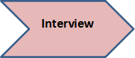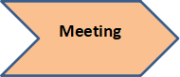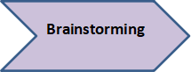**Communication**

**Figure 3.3:** Communication

In the pursuit of understanding the dynamics of our research topic, effective communication emerges as a fundamental element in our investigative process. As researchers, we recognize the significance of acquiring accurate and insightful information from various sources. This section explores the complex web of communication techniques used during our investigation. Our research journey has been enriched by the exchange of ideas, data, and insights, from conducting interviews and surveys to encouraging collaborative brainstorming sessions. Respondents in the HR Office provided information to the researchers about what problem they are facing particularly in finding their employees documents.

**Planning**

|  |  |  |  |  |  |  |
| --- | --- | --- | --- | --- | --- | --- |
| **Analysis** |  |  |  |  |  |  |
| **Design** |  |  |  |  |  |  |
| **Development** |  |  |  |  |  |  |
| **Testing** |  |  |  |  |  |  |
| **Implementation** |  |  |  |  |  |  |
|  | July | August | September | October | November | December |

**Figure 3.4.** Gantt chart

As we delve into Chapter 3 planning, our focus now shifts to the systematic approaches and strategic planning that constitute the foundation for the investigation of employee performance and engagement within local government organizations. The schedule for creating the system project is displayed in the chart. As shown in the Table, we must monitor progress for each month beginning in July and continuing through December in order to complete the system. Researchers gathered data including the positions of the LGU employees, the number of employees inside every office/department, and the problems they’re facing in retrieving documents.

**System Flowchart**

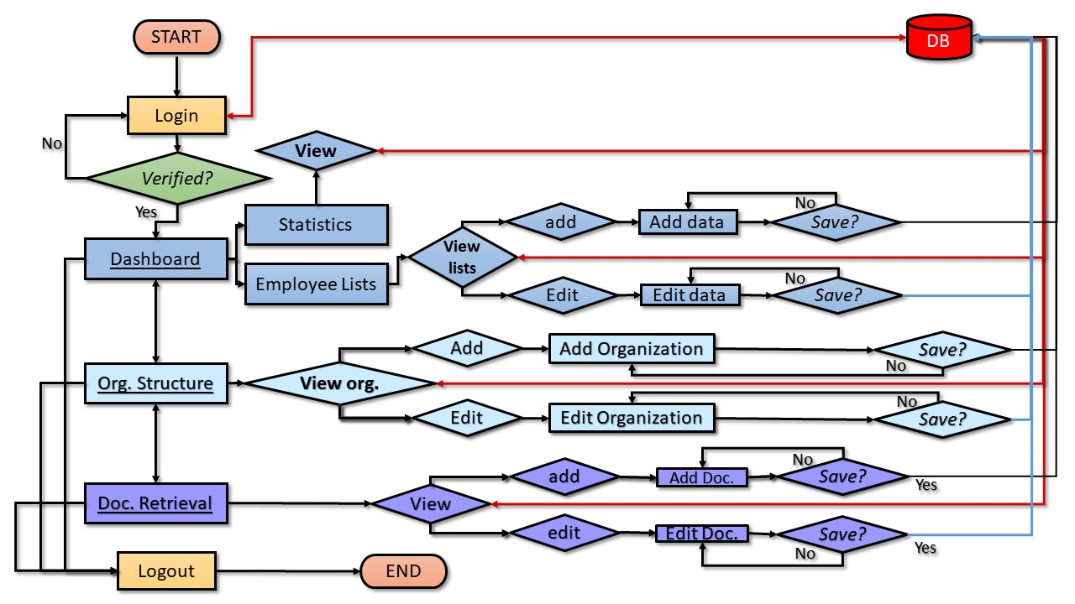

**Figure 3.5:** AdminSystem Flowchart

The operation of the system depends on the user type, namely Admin and User. Figure 3.5 represents the Admin flowchart and figure 3.6 represents the User. the admin has the functions to add and edit data in the system, while the user can only add data. The reason for this is security of data and also we based on the interview we conducted moreover they also indicate the delete function must not be included.

When the Admin or User log in to the system upon verifying the username and password from the database DB. The system will prompt three main options, the dashboard, organizational structure and document retrieval. In figure A indicates the dashboard has two sub options the statistics and the employee lists both have a view function but the employee lists has an add and edit functions. The organizational structure and document retrieval will have the view, add and edit functions for the admin shown.

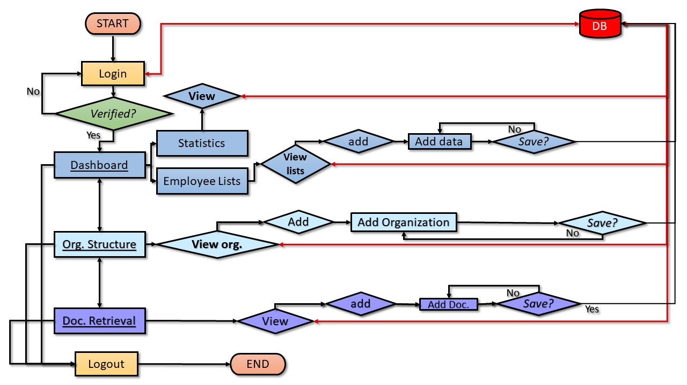

**Figure 3.6:** UserSystem Flowchart

The flow of the system and data for the User is the same with Admin this time without an edit function show in Figure B. The user has also the three main options and the same contents. The User can view or add data to the system. All the functions and features of the system is connected to the database. From longing in down to adding or editing documents.

**System Diagram**

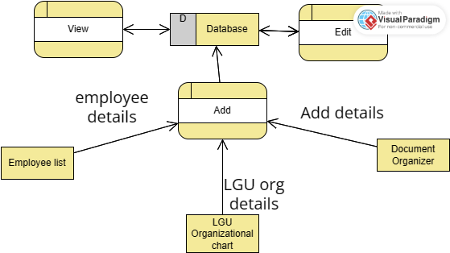

**Figure 3.7:** Data Flow Diagram

A data flow diagram represents the flow of every data that will be input into the system. Upon observing the researchers made this data flow that will show how the data will be added to the database. The figure shows how well the data runs through the system itself, the figure shows how will the data run through the system, all entities have an feature where they can store and add data to the database and it is connected to the database where all data will be stored and from the database the user can edit the data through the system and finally they can also view it as we fetch all the data from the database.

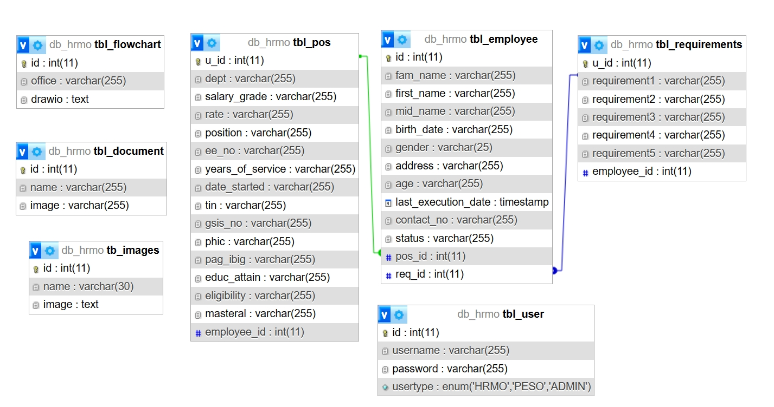**Data Schema**

**Figure 3.8:** Data Schema

The data schema serves as a fundamental cornerstone of any system. It functions as the bedrock upon which all data is stored, ensuring not only the cleanliness of the database but also optimizing it by eliminating data redundancy. Meticulously crafted by researchers, this data schema allocates ample space for accommodating data while pre-emptively sidestepping the menace of data overload. The database itself finds its genesis in the meticulously curated data furnished by the HRMO personnel.

**System Architecture**

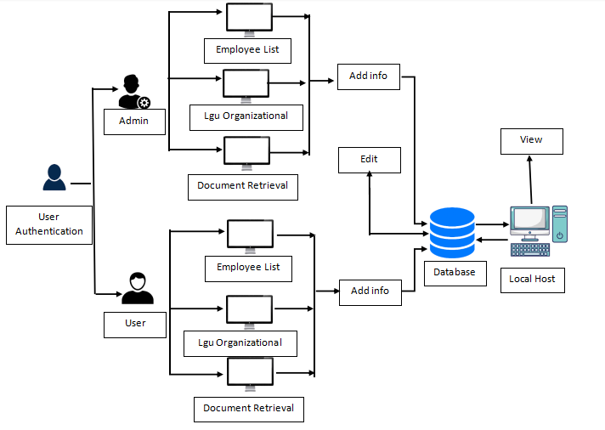

**Figure 3.8:** System Architecture

This figure presents a visual representation of the system. As depicted, the system incorporates two levels of user authentication: regular users and administrators. The administrator holds the privilege to add and modify any inaccurate information within the system. Once added or altered, all information will be securely stored within the database. Notably, the system lacks a deletion feature. This design choice aligns with feedback from our respondents, particularly the HRMO of LGU Carigara. They express a preference for retaining all data due to its sensitive nature, necessitating the preservation of records.

Conversely, regular users possess the capability to input necessary information into the system. However, their access is restricted to ensure data security and prevent any unauthorized data tampering.

**Deployment**

The researcher will launch of the developed HR management system within the HR Department of the Carigara Local Government Unit (LGU). To deploy our system, there will be several steps.

Firstly, the researchers will set a suitable deployment date, taking into account the operational availability of the Carigara Local Government Unit's HR department. This aims to minimize disruptions during the transition. Secondly, during the deployment, the research team will conduct comprehensive sessions to guide the installation, operations, and exploration of the system's diverse functionalities and features. These interactive demonstrations will empower LGU personnel to confidently navigate the software. Furthermore, the researchers will engage closely with the intended users, providing hands-on guidance to ensure their familiarity with the system's interface and capabilities. This step facilitates a seamless transition to the HR management system to ensure efficient utilization.

**Evaluation**

As we deployed our system, the stakeholders, including LGU’s HR department, were very happy because the system we made went beyond their expectations and was very helpful for their work. Since it works well and significantly reduces the time and effort required to locate and manage HR documents.

**CHAPTER IV**

**PRESENTATION, ANALYSIS, AND INTERPRETATION OF DATA**

Effective HR management techniques are of the utmost importance for local government units (LGUs) to provide citizens with high-quality public services. Unfortunately, a lot of local government units (LGUs) struggle to manage their workforces efficiently because they lack information-driven choices, and have antiquated HR systems, and limited resources. An HRMS with prescriptive insights is a data-driven system that can provide HR members and employees recommendations on how to improve workforce performance. These recommendations can be based on a variety of factors, such as organizational objectives, personnel abilities, and performance information. The researchers focused their efforts on creating a strategy that will make it easier for the employees to complete their tasks.

The study's proponents believe that the suggested system, which is discussed in the chapter before this one, may be finalized as stated above.

The Carigara Local Government Unit (LGU) is committed to improving its HR management practices and has recognized the potential benefits of implementing an HRMS. Moreover, this thesis research aims to develop an HRMS with prescriptive insights for the Carigara LGU that will help the LGU to optimize its workforce and achieve its organizational goals. The table below provides a summary of the responses given to the survey questionnaire statements. For ease of reference, the responses have been organized.

Table 1, which is displayed on the following page, indicates that, of the 320 replies, 167 fall into the Strongly Agree category, 150 fall into Agree, 3 for Undecided, 0 into Disagree, and 0 under Strongly Disagree. The vast majority of participants were quite convinced by the system's effectiveness.

|  |  |  |  |  |  |  |
| --- | --- | --- | --- | --- | --- | --- |
| **Statement** | **5** | **4** | **3** | **2** | **1** | **Total** |
| **1** | **46** | **18** | **0** | **0** | **0** | **64** |
| **2** | **29** | **35** | **0** | **0** | **0** | **64** |
| **3** | **31** | **33** | **0** | **0** | **0** | **64** |
| **4** | **28** | **35** | **1** | **0** | **0** | **64** |
| **5** | **33** | **29** | **2** | **0** | **0** | **64** |
| **Total** | **167** | **150** | **3** | **0** | **0** | **320** |

Table 1. The Effectiveness of the suggested system as perceived by the respondents.

|  |  |  |
| --- | --- | --- |
|  |  |  |

Conversely, Table 2 displays the survey results about the efficiency of the Strategic Workforce Optimization Development of HR Management System. The table shows that, of the 256 replies, 120 are classified as Strongly Agree and 133 as Agree, 3 for Undecided, and we got 0 for both Strongly Disagree and Disagree.

|  |  |  |  |  |  |  |
| --- | --- | --- | --- | --- | --- | --- |
| **Statement** | **5** | **4** | **3** | **2** | **1** | **Total** |
| **1** | **34** | **30** | **0** | **0** | **0** | **64** |
| **2** | **24** | **40** | **0** | **0** | **0** | **64** |
| **3** | **30** | **32** | **2** | **0** | **0** | **64** |
| **4** | **32** | **31** | **1** | **0** | **0** | **64** |
| **Total** | **120** | **133** | **3** | **0** | **0** | **256** |

Table 2. Respondent’s perception on the Efficiency of the proposed system.

|  |  |
| --- | --- |
|  |  |

|  |  |  |  |  |  |  |
| --- | --- | --- | --- | --- | --- | --- |
| **Statement** | **5** | **4** | **3** | **2** | **1** | **Total** |
| **1** | **53** | **11** | **0** | **0** | **0** | **64** |
| **2** | **29** | **35** | **0** | **0** | **0** | **64** |
| **3** | **22** | **42** | **0** | **0** | **0** | **64** |
| **4** | **21** | **39** | **4** | **0** | **0** | **64** |
| **5** | **28** | **33** | **3** | **0** | **0** | **64** |
| **Total** | **153** | **160** | **7** | **0** | **0** | **320** |

Table 3. Respondent’s perception of the Usability of the proposed system

|  |  |
| --- | --- |
|  |  |

The results of the survey about the usability of the proposed system in HR are displayed in Table 3. According to the table, 153 of the 320 total responses are in the Strongly Agree category, 160 are in the Agree category, 7 for Undecided, and for Strongly Disagree and Disagree we got 0.

Table 4. Respondent’s perception of the effectiveness of the satisfaction of the proposed system

|  |  |  |  |  |  |  |
| --- | --- | --- | --- | --- | --- | --- |
| **Statement** | **Strongly Agree** | **Agree** | **Undecided** | **Disagree** | **Strongly Disagree** | **Total** |
| **1** | **35** | **29** | **0** | **0** | **0** | **64** |
| **2** | **30** | **30** | **4** | **0** | **0** | **64** |
| **3** | **33** | **26** | **5** | **0** | **0** | **64** |
| **Total** | **98** | **85** | **9** | **0** | **0** | **192** |

In Table 4 provides a nuanced understanding of respondents' satisfaction levels with the functionality of the system. 98 responses clearly indicated that they were satisfied with the system by selecting "Strongly Agree," demonstrating that they strongly agreed with its features and functionalities. Furthermore, 85 respondents expressed agreement by choosing "Agree," which added to the positive assessment of the system's operation. Although 9 responses were “Undecided”, the overall satisfaction rate stands at 51%.

Table 5. Respondent’s perception of the effectiveness of the freedom from risk of the proposed system

|  |  |  |  |  |  |  |
| --- | --- | --- | --- | --- | --- | --- |
| **Statement** | **Strongly Agree** | **Agree** | **Undecided** | **Disagree** | **Strongly Disagree** | **Total** |
| **1** | **26** | **38** | **0** | **0** | **0** | **64** |
| **2** | **25** | **37** | **2** | **0** | **0** | **64** |
| **3** | **30** | **31** | **3** | **0** | **0** | **64** |
| **4** | **30** | **31** | **3** | **0** | **0** | **64** |
| **Total** | **111** | **137** | **8** | **0** | **0** | **256** |

The findings, as highlighted in Table 5, underscore the paramount importance accorded by participants to the security of information within the proposed system. A substantial 43% of respondents expressed confidence in the system's ability to handle information securely. This resonates strongly in the survey results, where 111 participants strongly agreed and 137 agreed that the system ensures data security.

Table 6. Respondent’s perception of the effectiveness of the Freedom from Content Coverage of the proposed system

|  |  |  |  |  |  |  |
| --- | --- | --- | --- | --- | --- | --- |
| **Statement** | **Strongly Agree** | **Agree** | **Undecided** | **Disagree** | **Strongly Disagree** | **Total** |
| **1** | **27** | **37** | **0** | **0** | **0** | **64** |
| **2** | **37** | **21** | **6** | **0** | **0** | **64** |
| **3** | **31** | **29** | **4** | **0** | **0** | **64** |
| **Total** | **95** | **87** | **10** | **0** | **0** | **192** |

Table 6, underscores the respondents' perceptions regarding the security features embedded within the proposed system. Notably, a substantial 95 participants expressed a resounding affirmation by selecting "Strongly Agree," indicating a high degree of trust in the security protocols put in place. Moreover, 87 more responses said they "Agree", while there were 10 participants who remained undecided.

**CHAPTER V**

**SUMMARY, RECOMMENDATION AND CONCLUSSION**

**Summary**

In response to the ever-evolving challenges encountered by the Carigara Local Government Unit in the realm of effective human resource management. The researcher’s aims to address the dynamic challenges faced by the Carigara Local Government Unit in managing its human resources effectively. The study focuses on the creation and implementation of an HR management system tailored to the specific needs of the organization. This system incorporates prescriptive insights, the goal is to optimize workforce efficiency, improve resource allocation, and foster overall organizational development within the local government unit. Therefore, the data gathering involved visits to the HRMO LGU Carigara, ensuring comprehensive data collection for employee information, document organization, and organizational structure and the features they want to include in the system.

Furthermore, to ensure that the system would be completed effectively, this study used the SDLC Software Development Life Cycle method in designing the system. The SDLC is a process used by software development teams to design, develop, test, and deploy high-quality software. The SDLC consists of a series of phases, each with its own set of activities, deliverables, and goals. It emphasizes a systematic and structured approach to software development, with a strong focus on testing throughout the entire development process.

The V- Model's give clarity and simplicity provided a straightforward path from requirements to testing, enhancing overall project comprehension and management. Its unique feature of allowing parallel development and testing activities facilitated an expedited timeline, enabling early detection and correction of defects. The researchers used this V-Model since when there are functions completed in the system, we show them to HR, so we know if we meet what they want and also if they will add more functions to the system. Ultimately, the V-Model's well-defined processes and suitability for our project's needs influenced its selection, contributing to a structured and efficient development lifecycle.

The HRMO Carigara Local Government Unit (LGU) were the respondents for this study. Since the researchers needed a sufficient sample size for the survey, we chose to include all employees inside the LGU’s department as respondents. The researchers used a survey questionnaire to standardize the data collection process. Each department of LGU’s was given a survey questionnaire to answer. The magnitude and intensity of the sample’s replies were also determined using a Likert scale.

Moreover ,descriptive statistics such as means and standard deviation have unclear meanings when applied to Likert Scale responses. So descriptive statistics cannot make any conclusion; it should not be used as the premise for testing a the hypothesis and making predictions or interpretations of the result. The researchers cannot truly establish if there is a significant effect of the system on the users if the data will not be treated statically. Hence, as a result, the F-test was used to determine the significance of the finding. The confidence level was set at 0.05 means null hypothesis is accepted, there is no significant difference. The proponents considered that various approaches to enhance comprehension of the system's operation and architecture, guaranteeing that the outcomes fulfil end-user demands and achieving the study's aims and objectives.

**Conclusion**

Strategic workforce optimization has become a vital part of efficient human resource (HR) management, allowing businesses to maximize performance and align employees to their strategic objectives. Strategic workforce optimization includes a range of practices used to optimize employees capabilities, composition, and skills in order to promote organizational effectiveness. LGUs face unique challenges in workforce optimization due to factors, ensuring the efficient and effective delivery of public services, Strategic Workforce plays a particularly important role.

Prescriptive insights integration with HR management systems (HRMS) presents a substantial opportunity for LGUs to improve their strategic capacities. Prescriptive insights-enabled HRMSs can suggest strategic workforce initiatives, spot any skills gaps, and offer insightful information about workforce patterns. Because of the complimentary services this study provides, both the organization and prospective clients benefited from it.

As a result, the researchers concluded that the Strategic Workforce Optimization Development of HR Management System with Prescriptive Insights for Carigara Local Government Unit should be implemented to addressed its workforce challenges, enhancing operational effectiveness, and ultimately improving the quality of public services delivered to its constituents. By embracing these practices, the LGU can position itself for long-term success and serve the community effectively.

**Recommendations**

The foundation of effective workforce optimization lies in the quality and accessibility of workforce data. The study's findings allow for the formulation of the following recommendations:

To increase the software system's independence from content coverage, more development should be done on it. This could be achieved by enhancing the flexibility and customizability of the current features or by adding new ones. To better understand how different user types perceive the software system, it should be evaluated with a wider and more diverse set of users. Once the software system is made available to the general public, it should be watched for user comments. The system can be further enhanced in the areas indicated by this input. All things considered, the data points to a promising and potentially effective software system.

**BIBLIOGRAPHY**

Abu Dhabi, United Arab Emirates

HR Analytics: A Modern Tool in HR for Predictive Decision Making

Journal of Management, 6(3), 2019, pp. 51-63

13 Pages Posted: 23 Feb 2020

Bandi, G. N. S., Rao, T. S. and Ali, S. S. (2021). *Data Analytics Applications for Human Resource Management.* International Conference on Computer Communication and Informatics (ICCCI), Coimbatore, India, 2021, pp. 1-5, doi: 10.1109/ICCCI50826.2021.9402300.

Chaves, E.F. & Sanchez, P.R. (2023). *Exploring the Evolution of Human Resource Analytics: A Bibliometric Study.* Retrieved from <https://doi.org/10.3390/bs13030244>

Chowdhury, et.al 2023. Unlocking the value of artiﬁcial intelligence in human resource management through AI capability framework. Human Resource Management Review 33: 100899

Civil Service Commission (CSC)(2007). Installantion of Perfomance Management System (PMS) in the Civil Service.‖ *Memorandum Circular No.7, s.2007.* Quezon City: Philippine Civil Service Commission.

Diliman College - Quezon City:Technological University of the Philippines - Manila. *A Research Study Analysis in the Academe Industry: Retrieve from:* <https://www.researchgate.net/publication/361306678>

Dr. Abdul Quddus Mohammed

Assistant Professor in Business (HR), Higher Colleges of Technology, Abu Dhabi, United Arab Emirates

Date Written: 2019

Ghani, B. et al., 2022. Challenges and Strategies for Employee Retention in the Hospitality Industry: A Review. Sustainability, 14(5), p. 2885.

Guest, D. E. (1997). Human resource management and performance: a review and research agenda. The International Journal of Human Resource Management, 8(3), 263–276. doi:10.1080/095851997341630

H. R. Madid, “Application of Data Analytics in the Human Resources Information System in Selected Companies in Metro Manila”, *IJMDES*, vol. 2, no. 6, pp. 37–54, Jun. 2023. Retrieved from: <https://journal.ijmdes.com/ijmdes/article/view/160>

Human Resource Management and Development Office (2013). B*atangas City Government (BCG) Employee Handbook.*

HR ANALYTICS: A MODERN TOOL IN HR FOR PREDICTIVE DECISION MAKING

Lepak, D. P., Liao, H., Chung, Y., & Harden, E. E. (n.d.). A Conceptual Review of Human Resource Management Systems in Strategic Human Resource Management Research. Research in Personnel and Human Resources Management, 217–271. doi:10.1016/s0742-7301(06)25006-0

10.1016/s0742-7301(06)25006-0

Mohammed, Dr. Abdul Quddus, HR Analytics: A Modern Tool in HR for Predictive Decision Making (2019). Journal of Management, 6(3), 2019, pp. 51-63, Available at SSRN: <https://ssrn.com/abstract=3525328>

Momin, W.Y.M., & Mishra, K. (2015). HR Analytics as a Strategic Workforce Planning. *International Journal of Applied Research,* 1(4), 258-260.

Mufamadi, F.S. (2010). *Performance Management Guide for Municipalities.* Department of Provincial and Local Government.

Nawaz, N. & Gomes, A., 2019. *Artificial Intelligence Chatbots are New Recruiters.* IJACSA) International Journal of Advanced Computer Science and Applications, 10(9).

Nyembezi, V. (2009). Development of a Performance Management System for the SABC.Nelson Mandela Metropolitan University Business School.

Prah Ruger, J., 2020. *Positive Public Health Ethics: Toward Flourishing and Resilient Communities and Individuals.* The American Journal of Bioethics, Volume 20(7), pp. 44-54.

Rousseau, Denise M., and Eric G. R. Barends. 2011. Becoming an evidence: Based HR practitioner. Human Resource Management Journal 21: 221–35.

Samtani, D. D. (2022). *The Advantages of Using Prescriptive Analytics in Recruitment and Performance Management processes by HR professionals based in Ireland* (Doctoral dissertation, Dublin, National College of Ireland).

Sanvictores, M. V., (2015). *Acceptability of the Strategic Performance Management System: Basis for an Action Plan* (*Unpublished masteral* *implementing and evaluating performance management systems. Philippines Local Government*: Society for Human Resource Management (SHRM) Foundation thesis). Lyceum of the Philippines University Batangas, Batangas City.

Shane, J.M. (2010). Performance management in police agencies: a Conceptual framework. *Policing: An International Journal of Police Strategies & Management, 33 (1), 6-29.* DOI <http://dx.doi.org/10.1108/13639511011020575>

Sun, B. (2009). *New Public Management*: Taipei: Bestbooks Publisher.

Sunlin, R. (2008). Common performance management challenges: Retrieved from <http://www.workinfo.com/free/downloads/135.htm>.

Journal of Management (JOM)

Volume 6, Issue 3, May - June 2019, pp. 51-63, Article ID: JOM_06_03_007 http://www.iaeme.com/JOM/issues.asp?JType=JOM&VType=6&IType=3

Journal Impact Factor (2019): 5.3165 (Calculated by GISI) www.jifactor.com

ISSN Print: 2347-3940 and ISSN Online: 2347-3959 © IAEME Publication

Wang, S., & Feeney, M. K. (2014). Determinants of Information and Communication Technology Adoption in Municipalities. The American Review of Public Administration, 46(3), 292–313. doi:10.1177/0275074014553462

10.1177/0275074014553462

**Appendices**

**Conducting Survey Questionnair**



